Images for Reflection from 2020 Convention Rollouts
Included in the folder as separate files
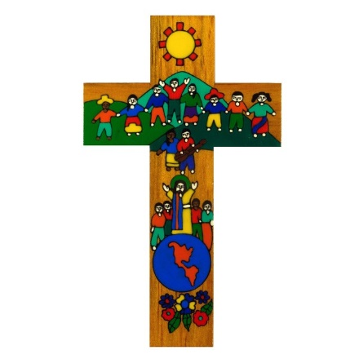
Source: https://www.amlaverty.co.uk/hand-painted-crosses/

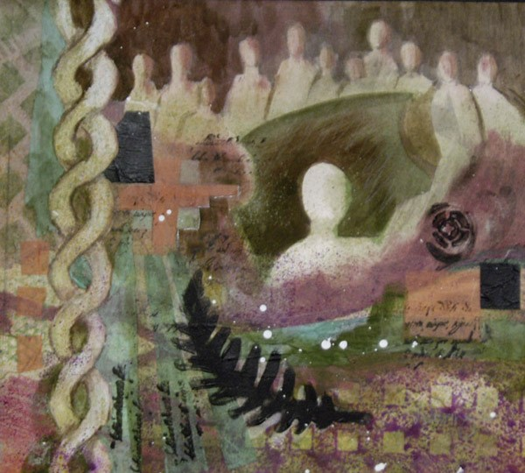

Meditation #7, mixed media. Virginia Wieringa

https://ecva.org/exhibition/HolyWomenHolyMen/030VirginiaWieringa-HWHM.htm

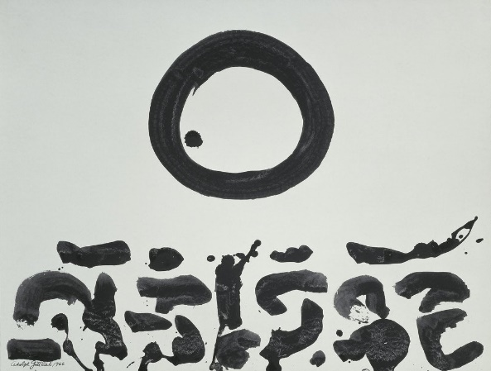

Adolph Gottlieb, Untitled, 1966, acrylic on paper, 18-7/8" x 24-1/8" (47.9 cm x 61.3 cm) © Estate of Adolph and Esther Gottlieb / Artists Rights Society (ARS), New York

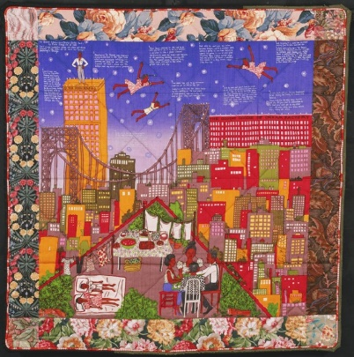
Faith Ringgold, Tar Beach II Quilt, 1990,Multicolored screenprint on silk plain weave, printed cotton plain weave, black and green synthetic moire, 66 x 67 inches (167.6 x 170.2 cm), © 1990 Faith Ringgold.
http://www.philamuseum.org/collections/permanent/86892.html

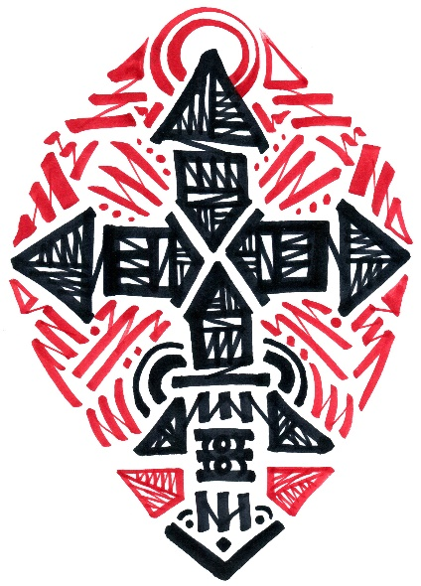
IMAGE CREDIT: CROSS by Kiriakos Prodis aka YAKO, designed for 9/9/2020 Convention Roll out

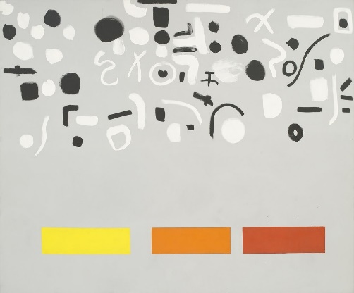
Adolph Gottlieb, Open Above, 1972, acrylic on canvas, 7' 6-1/8" x 9' 1/8" (228.9 cm x 274.6 cm) © Estate of Adolph and Esther Gottlieb / Artists Rights Society (ARS), New York

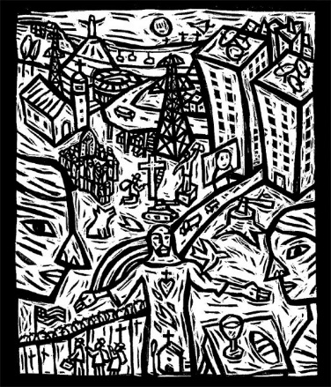
The Son of Man, black ink on paper. Ernesto Lozada Uzuriaga
https://ecva.org/exhibition/HolyWomenHolyMen/018ErnestoLozada-Uzuriaga-HWHM.htm

