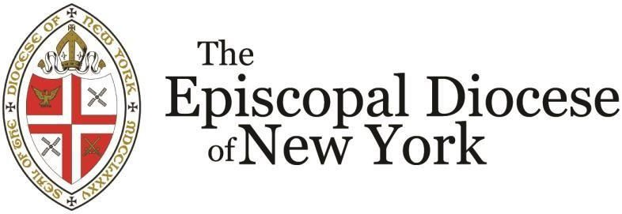

CONGREGATIONAL DEVELOPMENT COMMISSION

FIRST STEPS GRANTS

2024 FUNDING GUIDELINES &
Interim/Final Report Form

Deadline: Friday, April 26, 2024

Congregational Development Commission: First Steps Grant

Introduction and Background
The Congregational Development Commission of the Episcopal Diocese of New York announces the availability of $30,000 of funding for grants of $5,000 each to Episcopal churches in the diocese.

The purpose of First Steps Grants is to grow the Episcopal Diocese of New York by creating stronger and healthier parishes. While all parishes are eligible to apply, the funds are specifically targeted to parishes with an ASA between 50 and 150. Funds awarded under this program are to support activities that will result in definable and measurable spiritual and numerical growth. First Steps Grants are not intended for general support, on-going program support or benevolence. It is exclusively a development fund.

First Steps Grants Schedule

1. April 26, 2024
2. May 17, 2024
3. May 31, 2024
4. Dec. 2024
5. May 31, 2024
Applications due (late applications not accepted) Decisions announced
Funds Distributed
Interim progress report due Final post-project evaluation due

Proposal Selection Process
A Committee of The Congregational Development Commission will review all proposals and make decisions regarding awards and grant amounts to be made. The Committee will evaluate and rate each proposal in terms of:

- Potential for producing spiritual growth
- Potential for being used successfully in other parishes
- Potential for producing numerical growth

Grantee Reporting Requirements
A Progress Evaluation Report is included in this packet, due at the completion of the project. Reports must include a financial accounting of all grant monies.

Examples of Types of Activities to Be Supported
A parish may submit proposals for a broad range of activities provided they can clearly explain how the project will result in spiritual and numerical growth. The following examples are not exclusive but are provided as illustrative of what may be considered. Creativity and innovation in ministry are encouraged.

- Visitor and Member tracking: A comprehensive strategy to provide on-going training and support of greeters/ushers.
- Improvements to physical plant: Equipment for a nursery, or youth and Christian education rooms. Increasing church’s “curb appeal.” (Please note that the Property

Support Committee has funds available for the purchase of materials for painting, plastering, etc., provided volunteer labor is used.)
- Youth and Young Adult: Program to raise up youth leaders. Partial salary for a part-time youth worker.
- Mission in the Community: Identifying a significant community need and effecting positive change, perhaps in partnership with other community groups, with a strategy for engaging the community spiritually.
Proposal Format and Content
Please complete the online form at www.dioceseny.org/first-steps-grants and use it to upload your supporting materials (see below) no later than end of day on the stated deadline day. Late applications cannot be accepted. Your supporting materials, which may be uploaded as a single or multiple files, should include the following:
  - Project Narrative
Narratives should not exceed one typewritten page, and should include:
    - A brief description of your parish and surrounding community in terms of geographic, racial, economic, and spiritual characteristics.
    - A brief description of the project’s potential for spiritual and numerical growth in your parish.
    - A brief description of the project’s potential for duplication in other parishes to similarly increase spiritual and numerical growth.
    - A timeline of major steps for the project.
  - Proposed Budget for the Project (not the church)
Provide a complete budget for the project. Identify sources of funding other than this grant.
  - Estimates & Bids for Professional Services (if any)
  - 2023 Parochial Report
How the Proposals Will Be Evaluated
Proposals will be reviewed and rated by a committee of the Congregational Life for Mission. The committee will make all award decisions based on their evaluation of the following:
- Potential for producing spiritual growth
- Potential for being used successfully in other parishes
- Potential for producing numerical growth

If you have questions, please contact the Rev. Canon Victor Conrado, Canon for Congregational Vitality, vconrado@dioceseny.org.

Parish Name:

Contact Person: Address: Phone:
Email: Project Title:

First Steps Grant Application Interim or Final Progress Report

Describe Progress in Meeting the Stated Objectives:
- Potential for producing spiritual growth
- Potential for being used successfully in other parishes
- Potential for producing numerical growth

Major Successes:

Obstacles Encountered:

Please attach a final financial report for the project with your final report.

