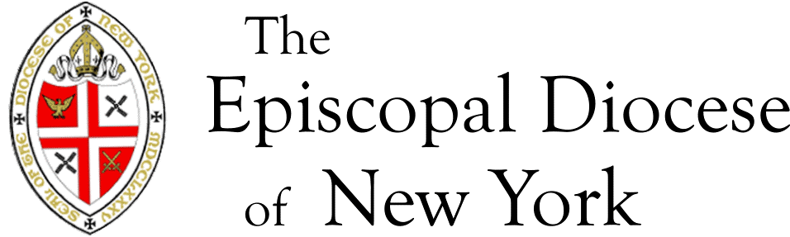

Direct Deposit Agreement Form

Authorization Agreement
I hereby authorize EDNY to initiate automatic deposits to my account at the financial institution named below. I also authorize EDNY to make withdrawals from this account in the event that a credit entry is made in error.
Further, I agree not to hold EDNY responsible for any delay or loss of funds due to incorrect or incomplete information supplied by me or by my financial institution or due to an error on the part of my financial institution in depositing funds to my account.
This agreement will remain in effect until EDNY receives a written notice of cancellation from me or my financial institution, or until I submit a new direct deposit form to the Payroll Department.

Account Information
Employee Name:
Name of Financial Institution:
Routing Number:
Account Number: |  | ☐ Checking | ☐ Savings

Signature
Please attach a voided check or deposit slip and return this form to the Payroll Department
Authorized Signature (Primary): |  | Date:
Authorized Signature (Joint): |  | Date:

